1.First we can login github account after that create new git repository.

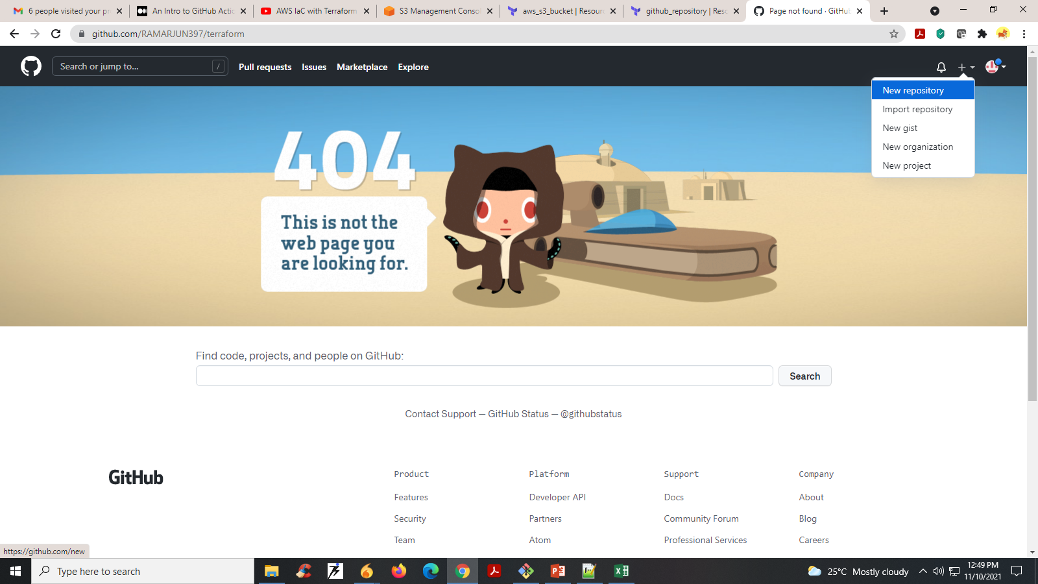

2. Here we can give repository name .

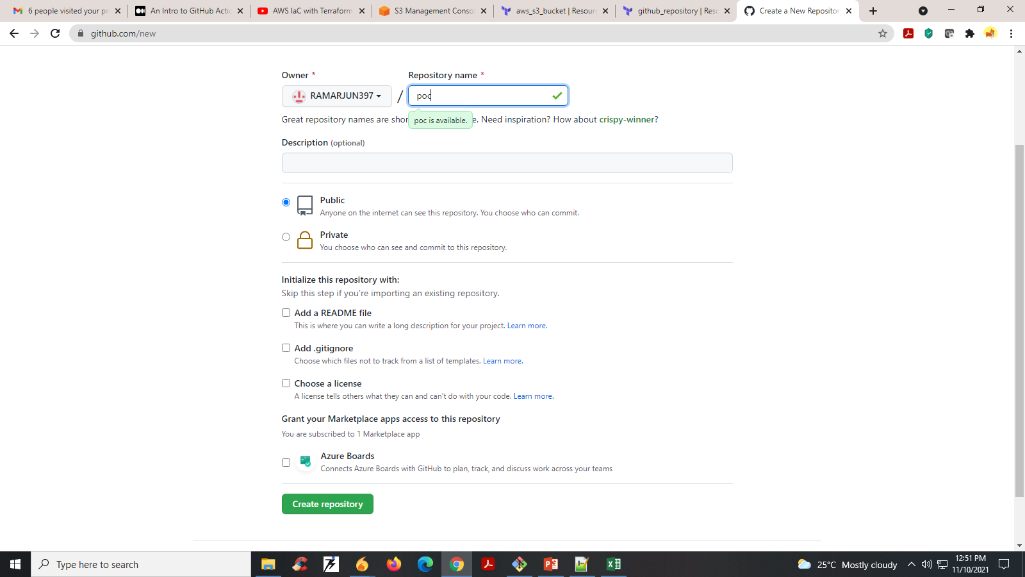

3. Next push our terraform code to GitHub repository using Git commands. After that the page look like.

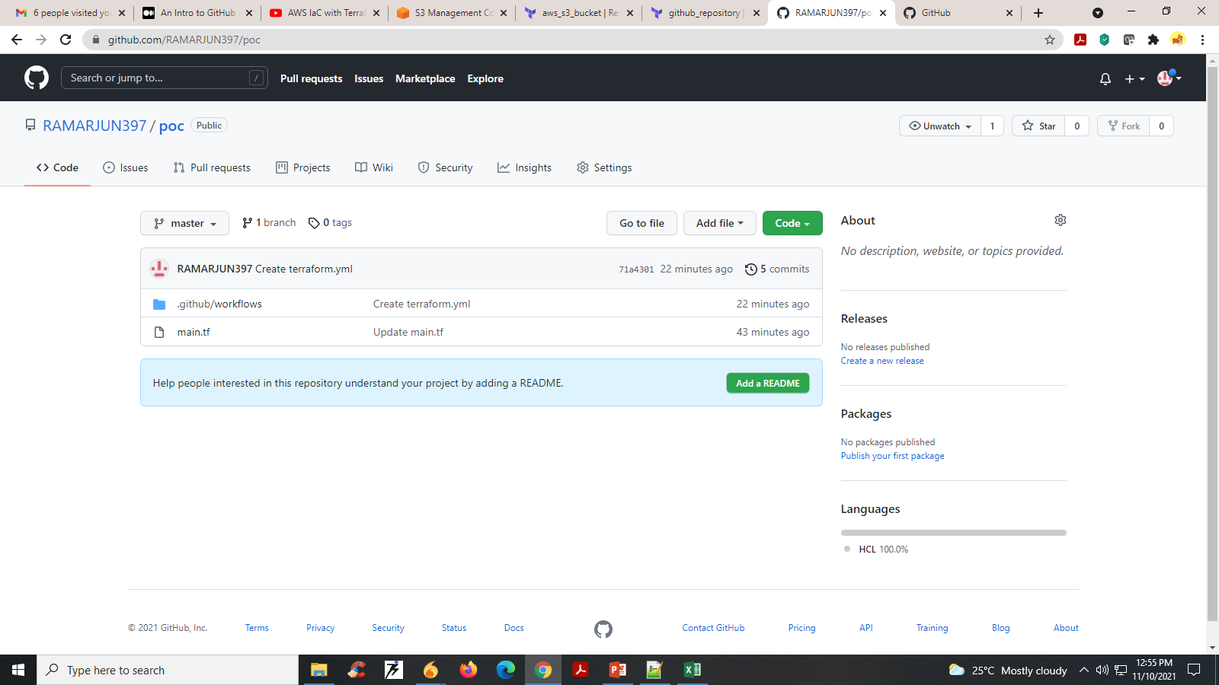

The main.tf contains the below code for creating s3 bucket in aws .

|  |  |  |  |  |  |  |  |  |  |  |  |  |  |  |  |  |  |  |  |  |  |  |  |  |  |  |  |  |  |  |  |  |  |  |  |  |  |  |  |
| --- | --- | --- | --- | --- | --- | --- | --- | --- | --- | --- | --- | --- | --- | --- | --- | --- | --- | --- | --- | --- | --- | --- | --- | --- | --- | --- | --- | --- | --- | --- | --- | --- | --- | --- | --- | --- | --- | --- | --- |
| |  | | --- | | terraform { | |  | required_version = ">=0.12.13" | |  | } | |  |  | |  | provider "aws" { | |  | region = "ap-southeast-1" | |  | access_key = "<Access-Key" | |  | secret_key = "<Secret-key>" | |  | } | |  |  | |  | #Aws s3bucket | |  | resource "aws_s3_bucket" "terraformsimplestorage3bucket" { | |  | bucket = "terraformsimplestorage3bucket" | |  | acl = "private" | |  |  | |  | tags = { | |  | Name = "terraformsimplestorage3bucket" | |  | Environment = "OPS" | |  | } | |  | } | |

4. Click On Actions and Scroll Down You Select Terraform setup Work space.

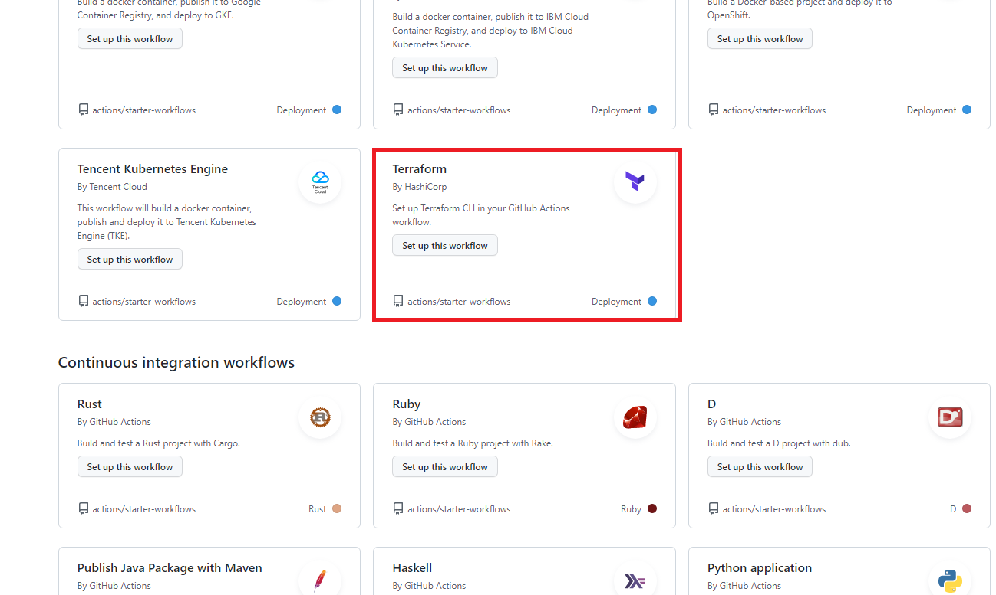

5. Ater that give terraform action plan name and after click start commit and Save that action plane.

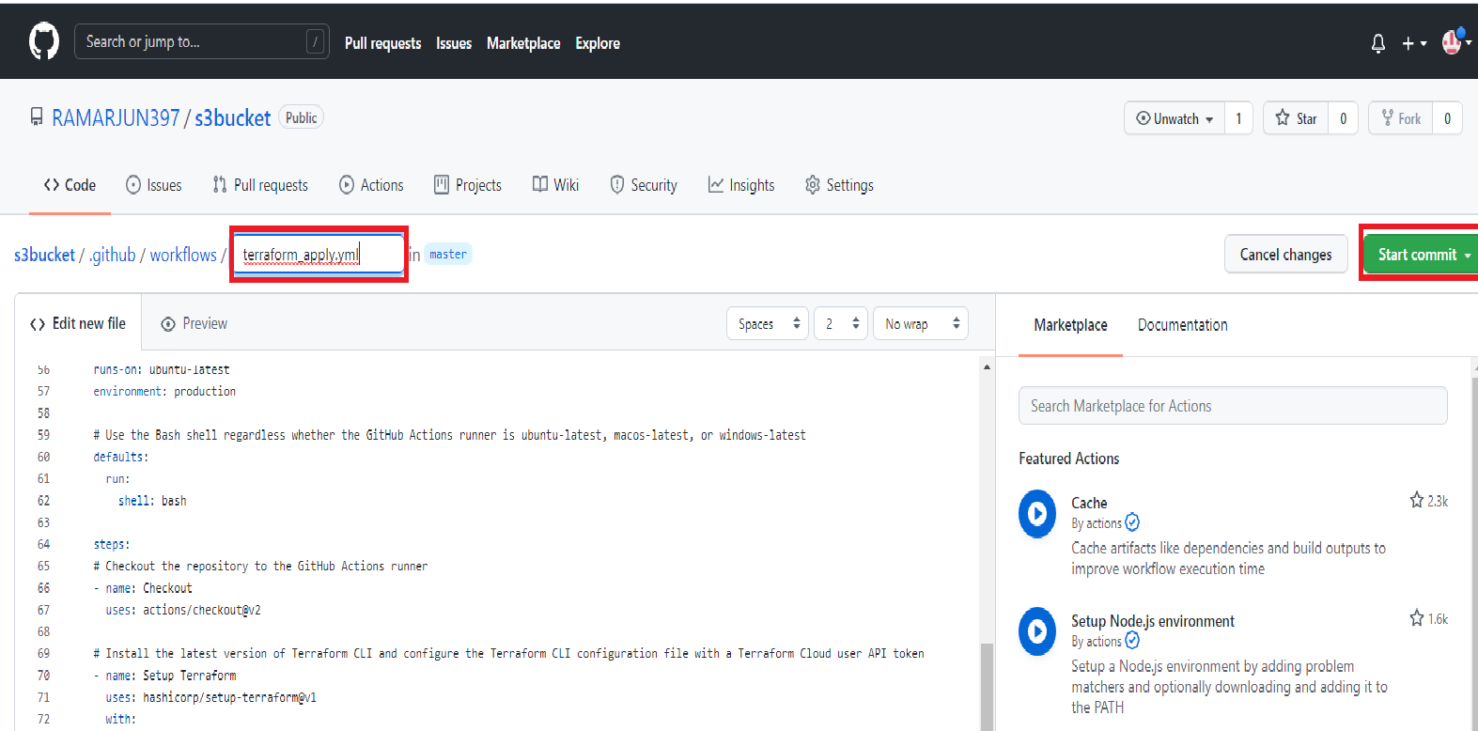

Terraform action plan yml file contains the following code.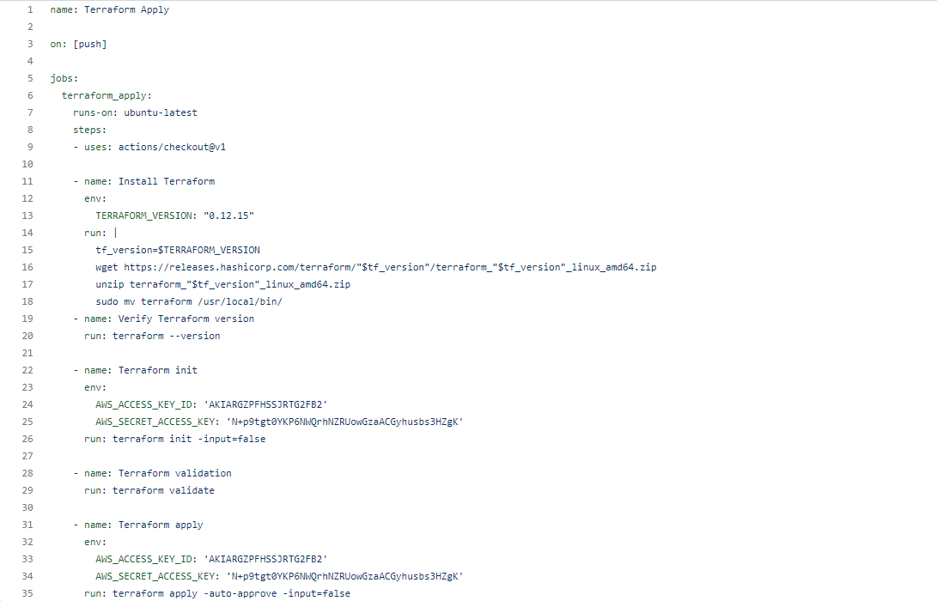

6. Goto Github action you will get the action plane.

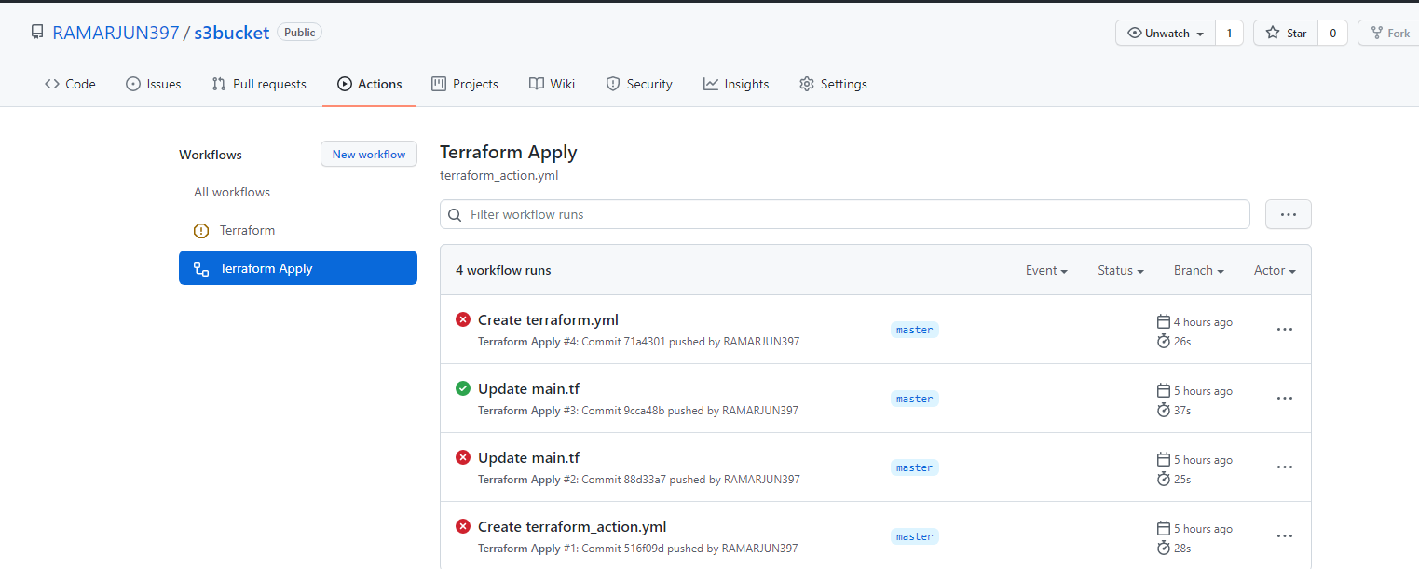

7. The action plan will be automatically running and create our required resources in in aws console.

